**RDS Assignment**

**Module 6 – Task 1**

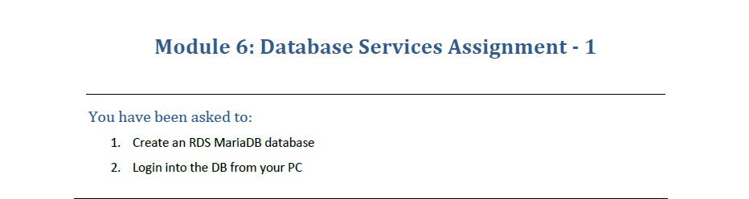

1. To create a RDS MariaDB Database, go to Amazon RDS and click on Create Databse.

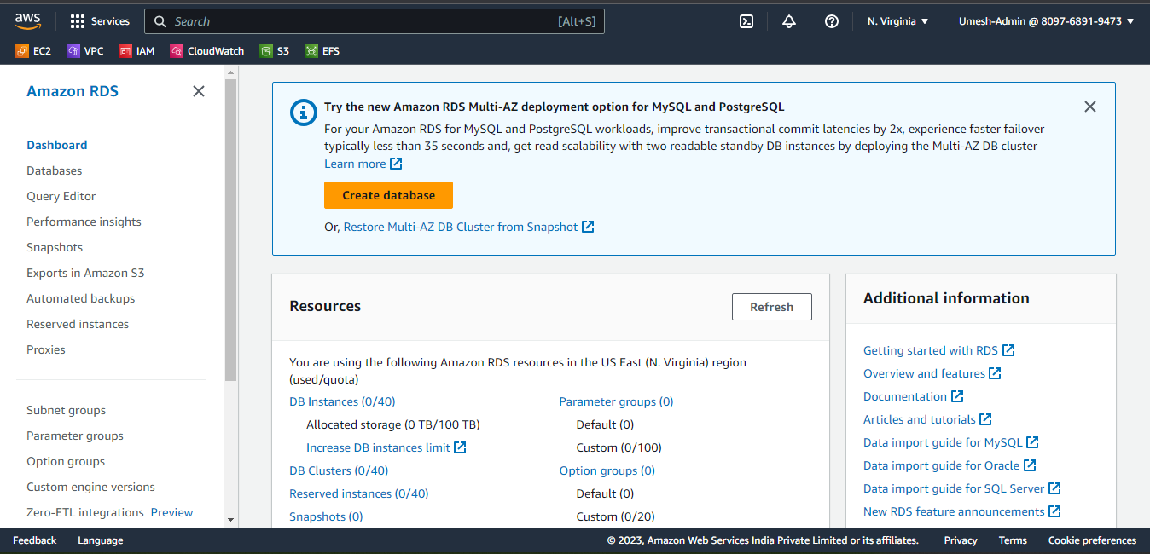

1. Select MariaDB as the Database and the desired Engine Version

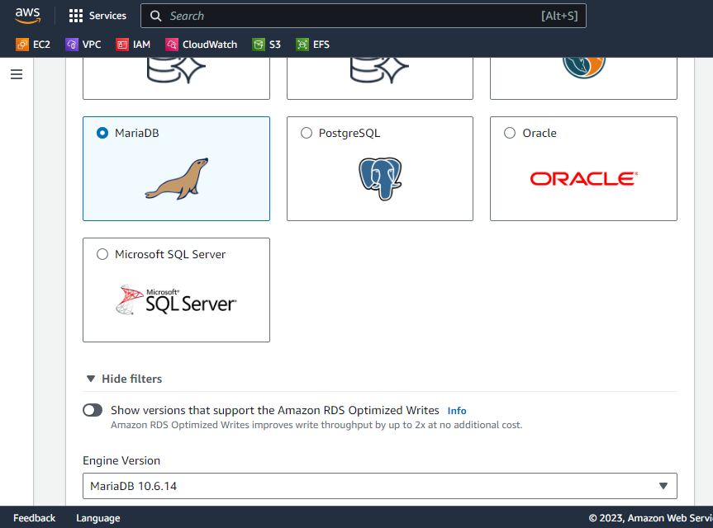

1. Setup the Master User and Password.
2. Create an Instance (to resemble PC)
3. Install mariadb package. Command : sudo dnf install mariadb105
4. Go to Database and Choose Option Set up EC2 Connection to connect your EC2 Instance with DB Instance

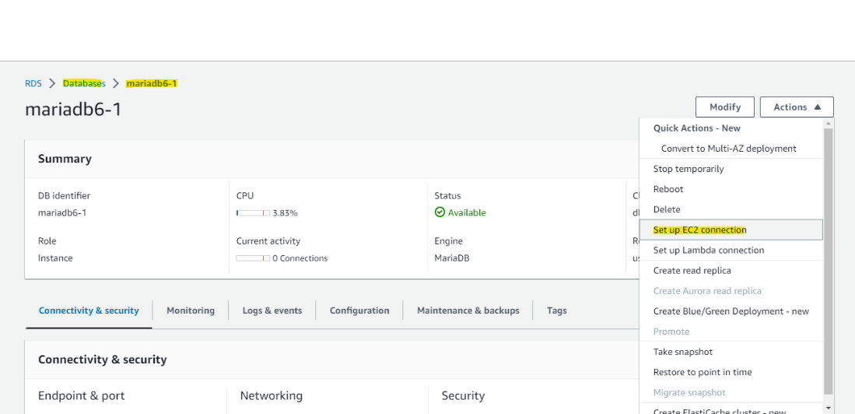

1. Choose the respective Instance and setup accordingly.
2. Go to RDS and under Connectivity & Security Tab. You will get the Endpoint and Port of the DB Instance, copy it.

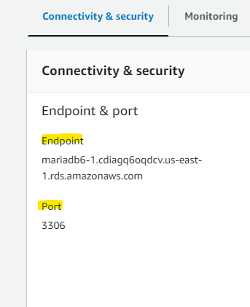

1. Connect to your EC2 Instance and use command :  
   mysql –h <endpoint> -p 3306 –u <MasterUser> -p
2. Enter the Password via EC2 Instance. You will be soon connected to the MariaDB Instance.

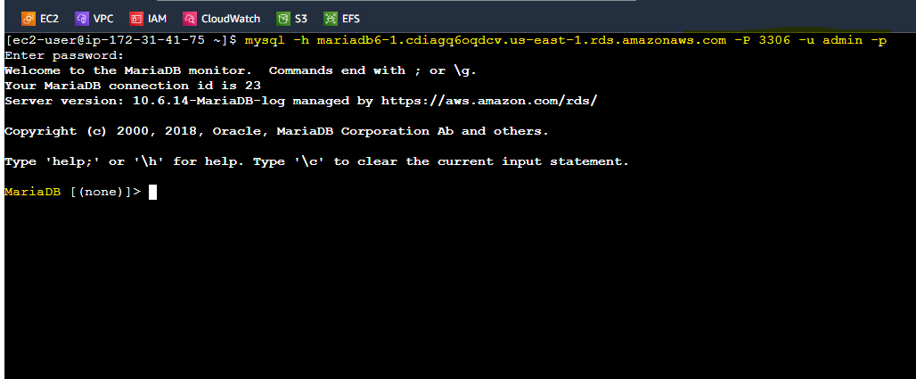

**RDS Assignment**

**Module 6 – Task 2**

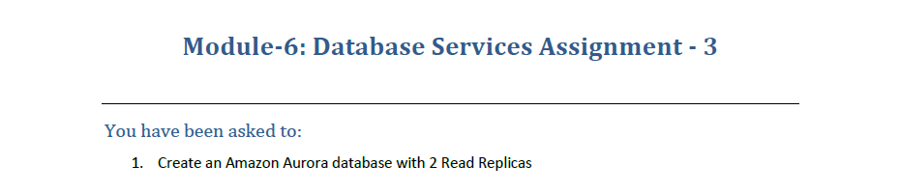

1. Go to Amazon RDS and Create a Database.
2. Select Aurora as the DB.

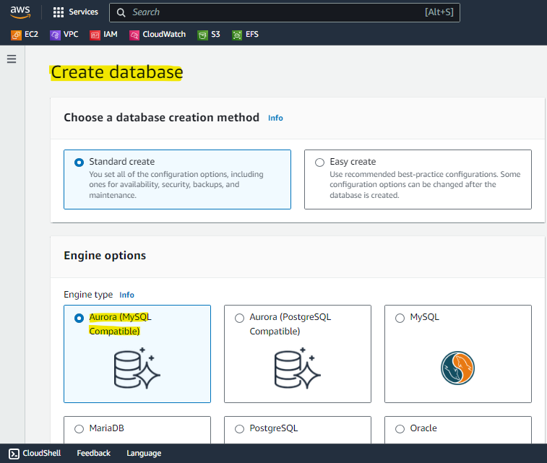

1. Make sure to Tick this Option to create a Read Replica.

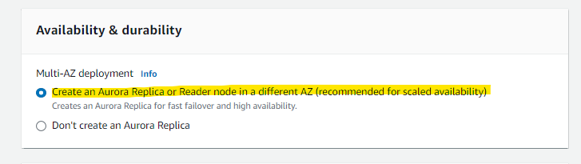

**RDS Assignment**

**Module 6 – Task 3**

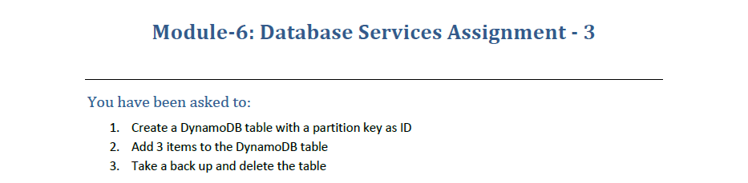

1. Go to DynamoDB Service and Create a Table.

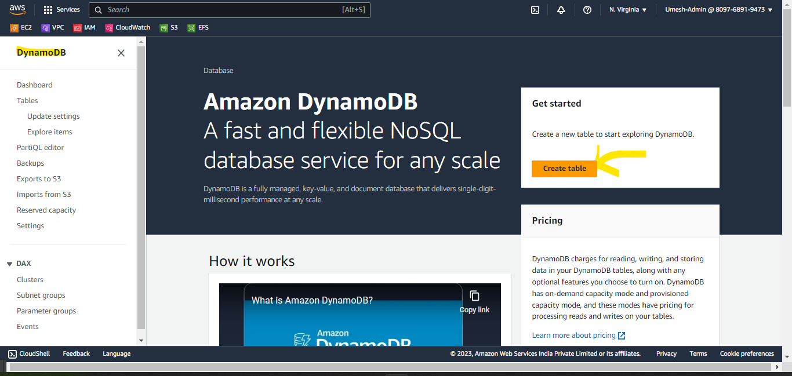

1. Create the Partition Key as ID.

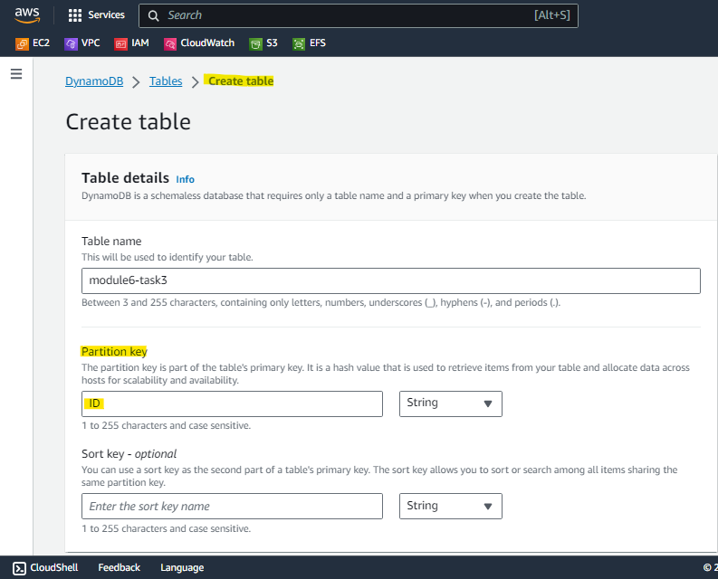

1. Select the Table and Select Actions > Create Item.

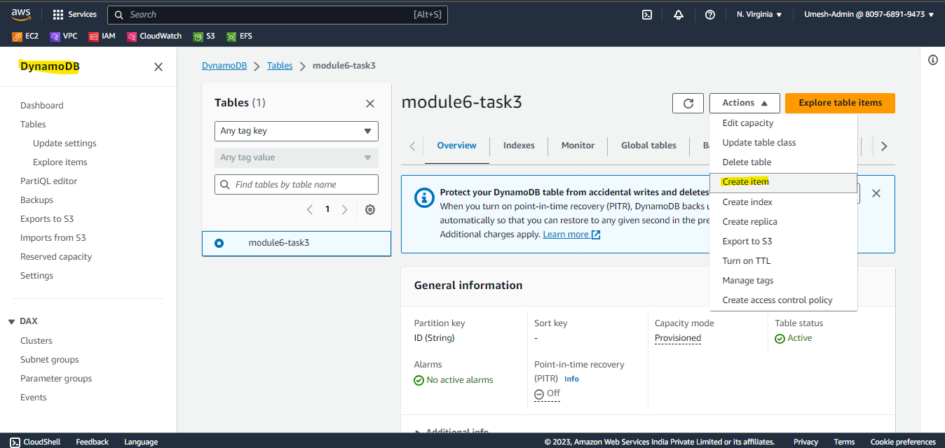

1. Create 3 Items.

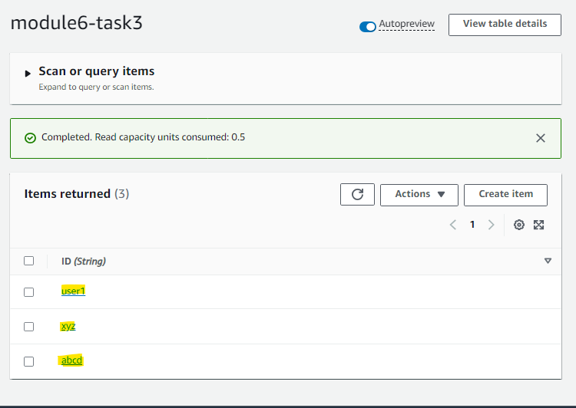

1. Go to Tables and select the DynamoDB Table. Under the Backups Tab, select Create Backup and choose Create on-demand Backup to backup the table contents.

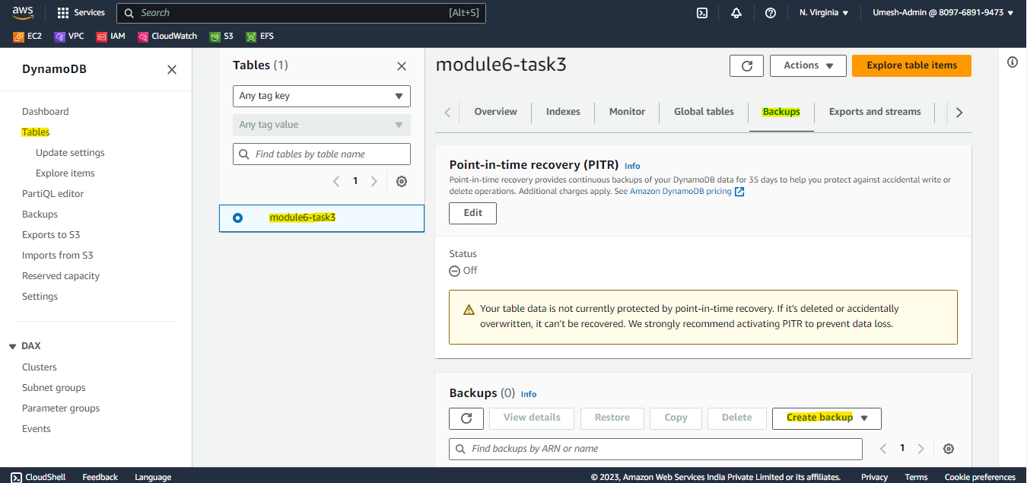

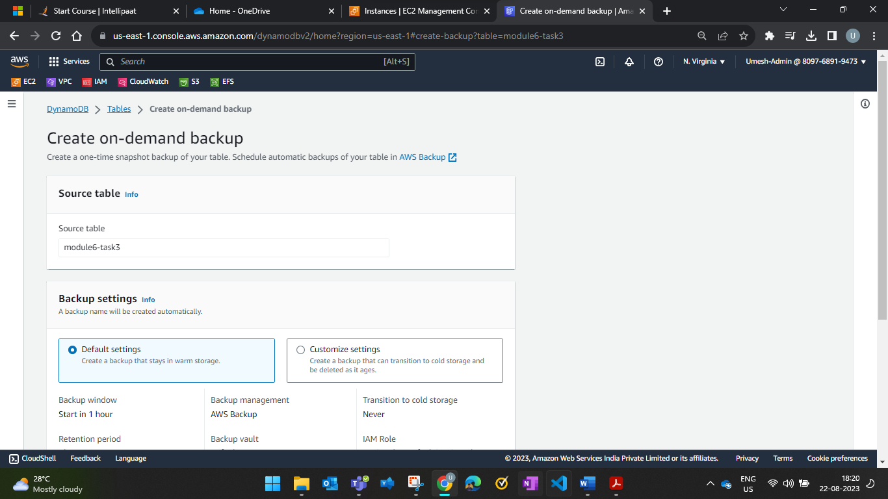

1. Now go to DynamoDB Page and select the Table and click on Delete to Delete the Table.

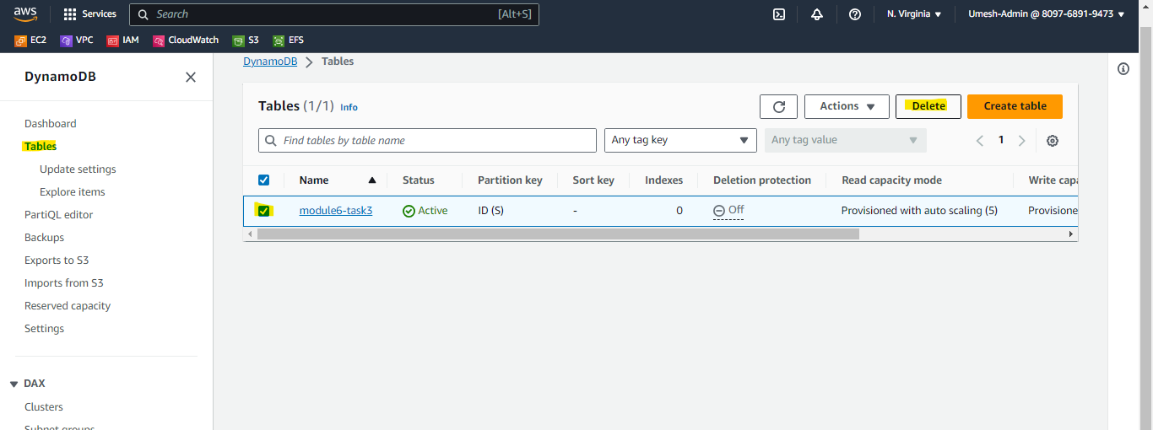

**RDS Assignment**

**Module 6 – Task 4**

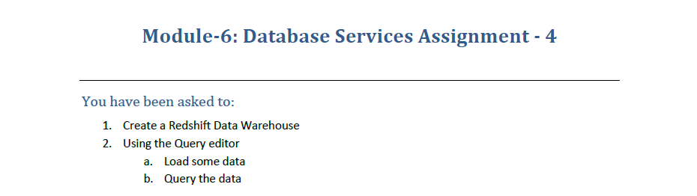

1. Open Amazon Redshift to create a Redshift Cluster and opt for Sample Data to query. Associate the respective IAM Role to access the cluster.

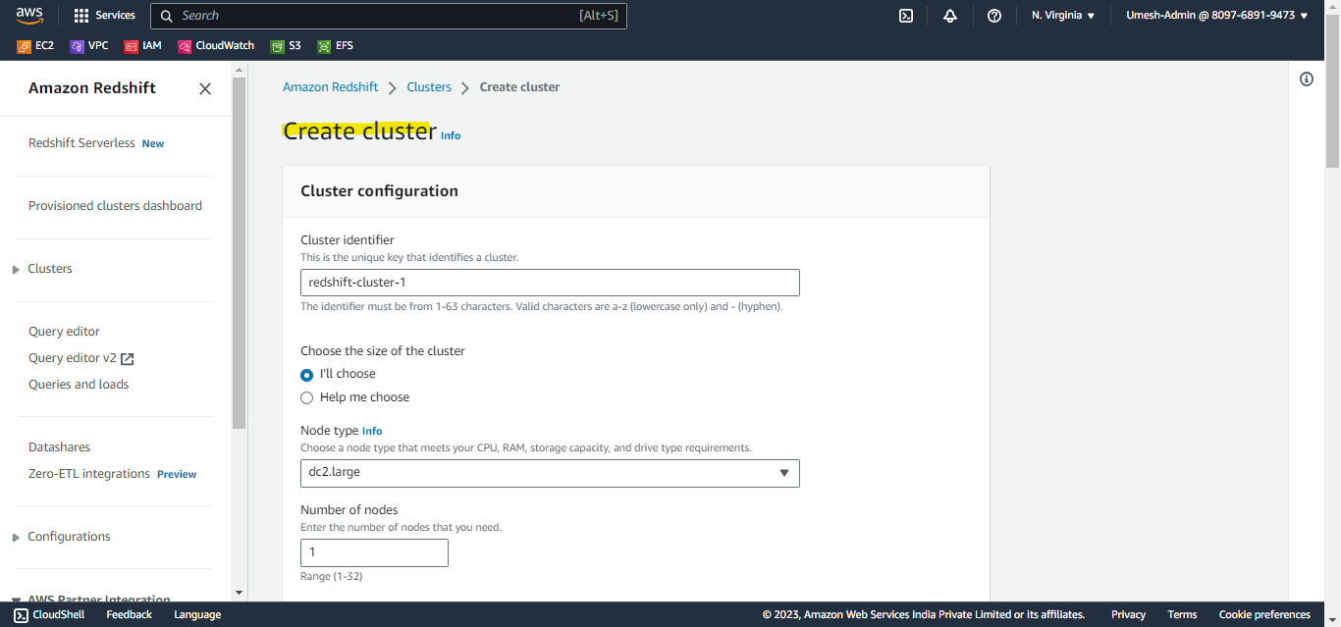

1. Once the Cluster is created, go to Query Editor to load and query the data.
2. Load the Demo Data

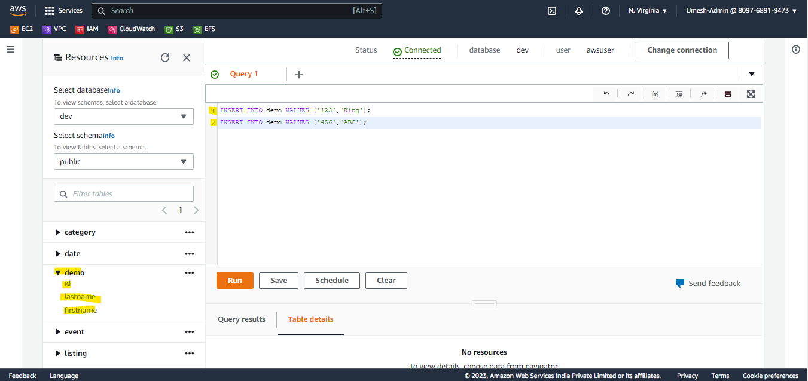

1. Query the Demo Data.

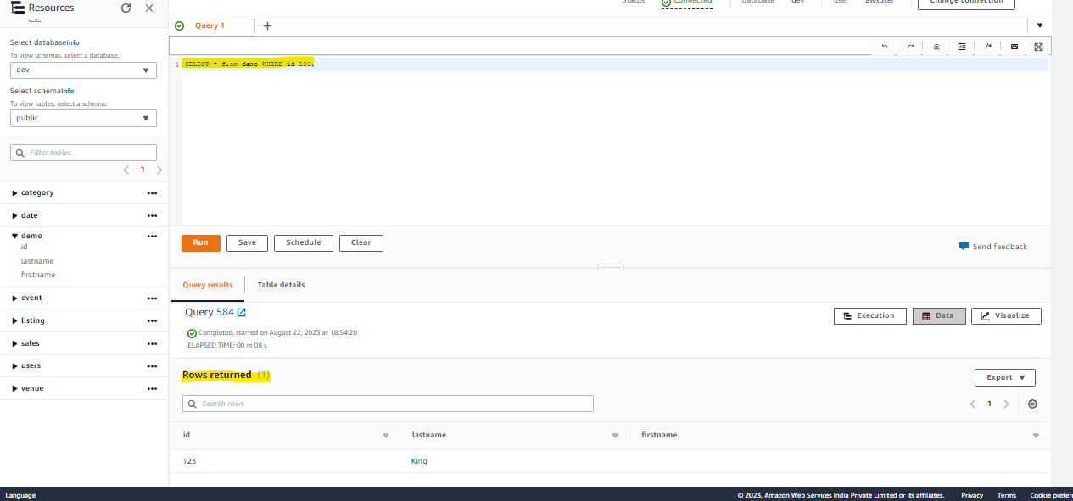

**RDS Assignment**

**Module 6 – Case Study**

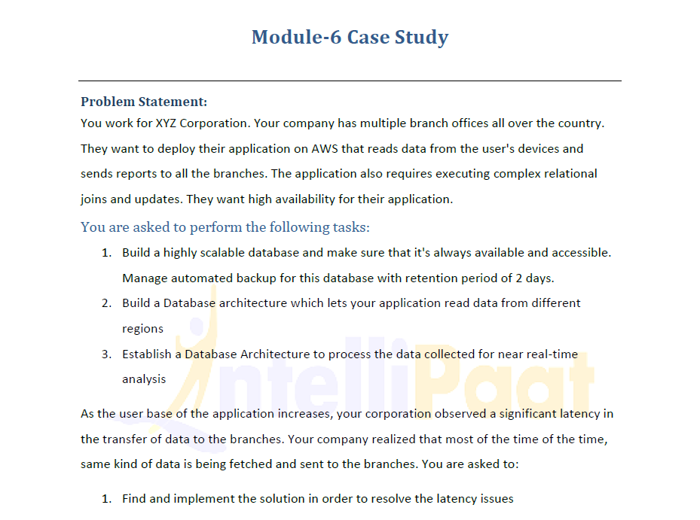

1. First, Create a Global Database (Aurora) to satisfy Task 2 (Access from different regions).

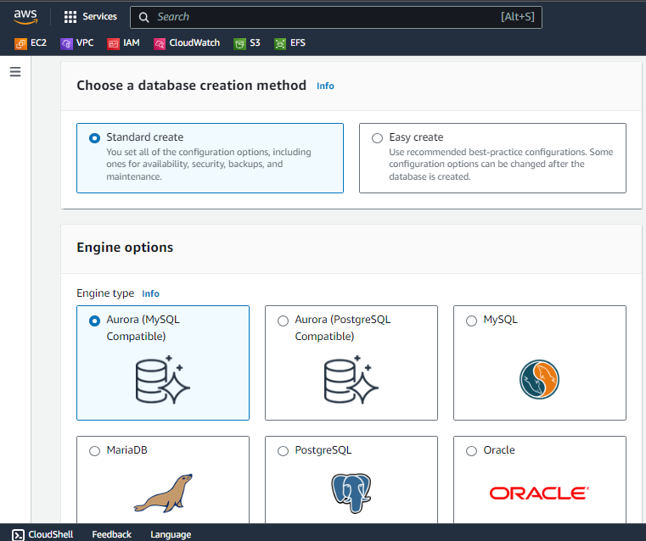

1. Choose Aurora Replica option to have a standby node (ensuring High Availability)

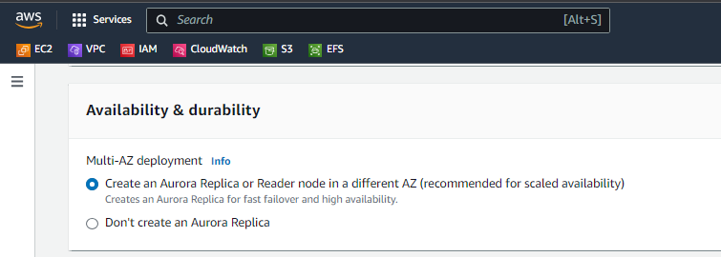

1. Go to Advanced Option and choose Backup Retention Period to 2 Days to satisfy our Case Study Clause.

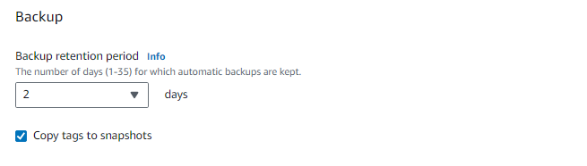

1. We have successfully built an always available and accessible DB with automated backup with retention period of 2 Days.
2. Now to read the data from different region, you have to scale the database and extend it’s reachability to different region by creating a cross-region read replica.

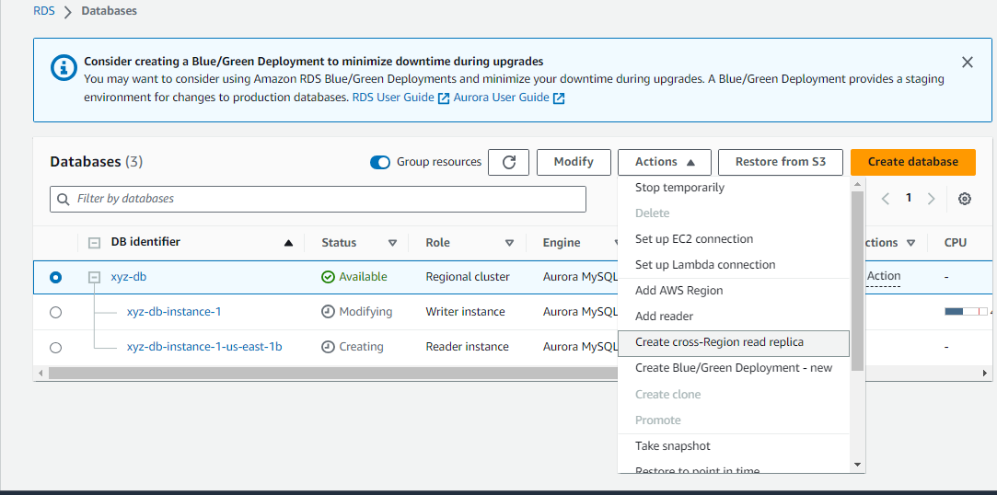

1. To process the data collected for near real-time analysis. You can build a lambda function to pull data from DB and further pass it on to Amazon Kinesis Data Streams to analyse the data in real time.
2. Since the data fetched is same most of the time. Create a Elasticache Cluster (Memcached) to Cache the Data and deliver it quickly to the user.

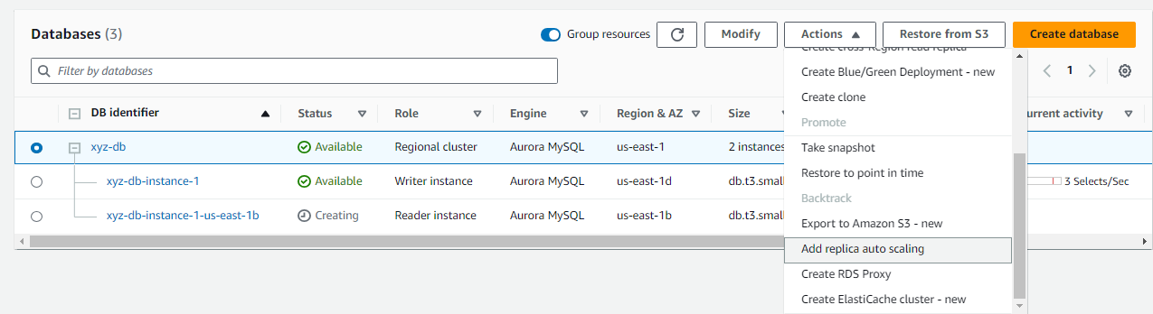

I couldn’t demonstrate the whole since most of the services are chargeable. I have demonstrated and explained the process.